# **44. NAT (STATIC): PART 1**

## **Private IPv4 Addresses (RFC 1918)**

* IPv4 doesn’t provide enough addresses for all devices that need an IP address in the modern world.
* The long-term solution is to switch to IPv6.
* There are three main short-term solutions:  
  + CIDR
  + Private IPv4 Address
  + NAT

RFC 1918 specifies the following IPv4 address ranges as private:  
  
10.0.0.0 /8 (10.0.0.0 to 10.255.255.255) CLASS A

172.16.0.0 /12 (172.16.0.0 to 172.31.255.255) CLASS B

192.168.0.0 /16 (192.168.0.0 to 192.168.255.255) CLASS C

* You are free to use these addresses in your networks. They don’t have to be globally unique.

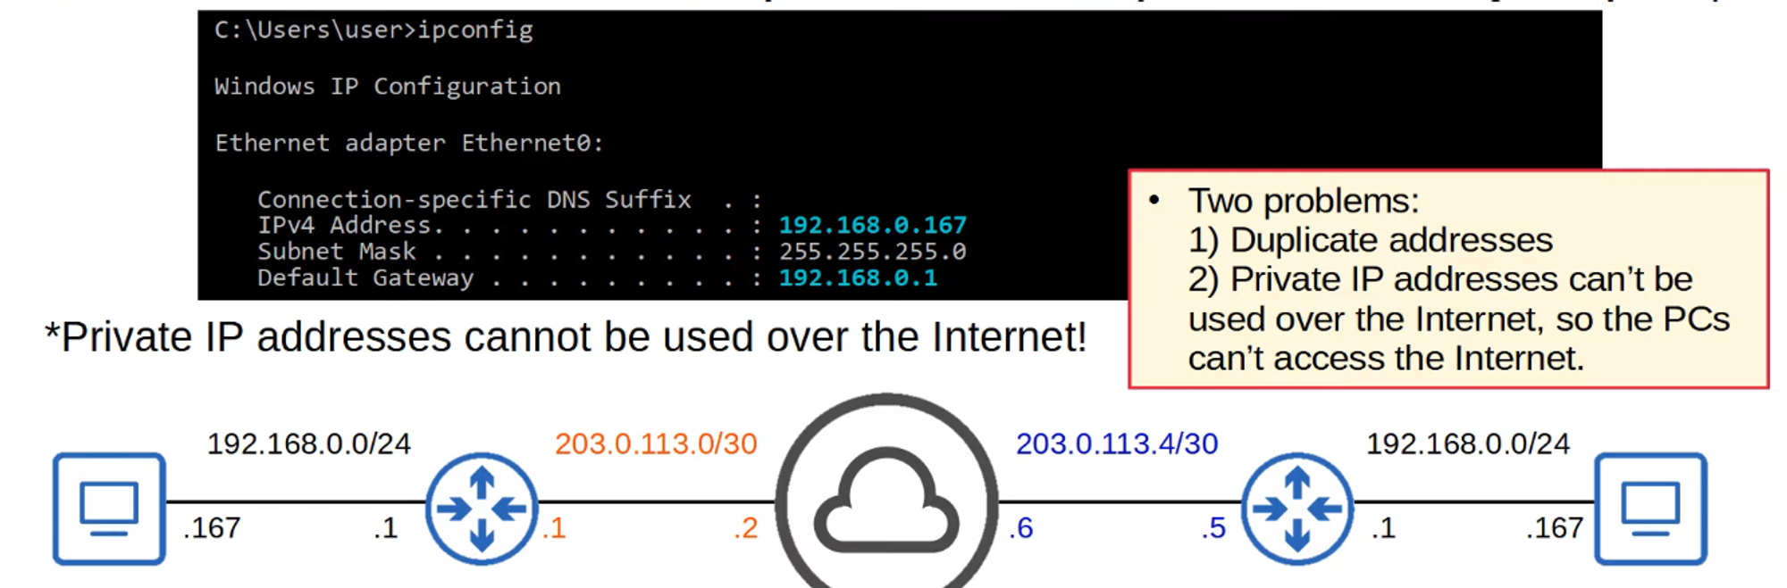

## **Introduction to NAT**

* **Network Address Translation (NAT)** is used to modify the source and/or destination IP addresses of packets.
* There are various reasons to use NAT, but the most common reason is to allow hosts with private IP addresses to communicate with other hosts over the internet.
* For the CCNA, you have to understand **Source NAT** and how to configure it on **Cisco routers**.

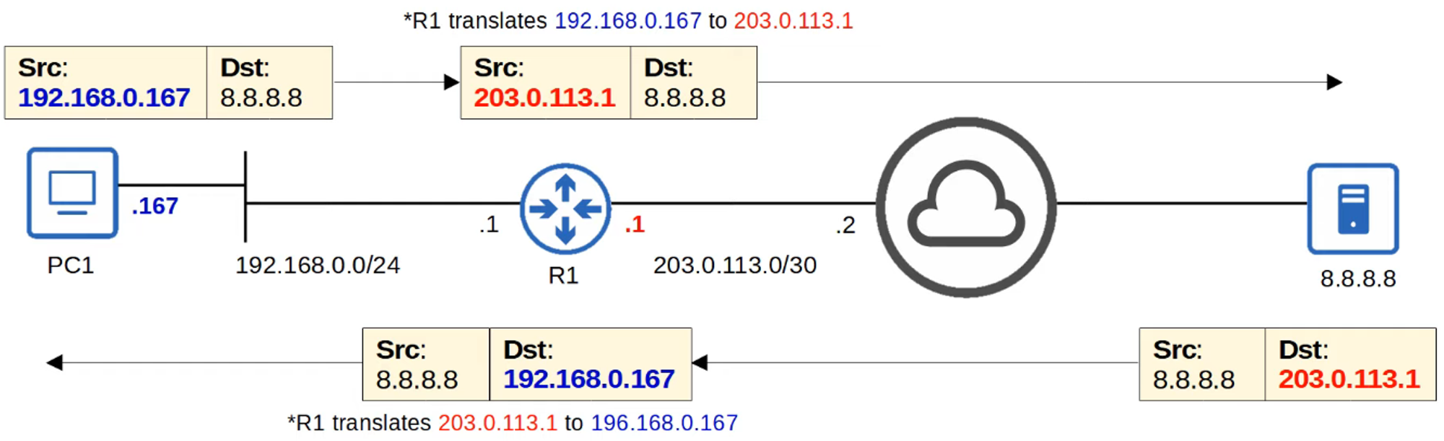

## **Static NAT**

* **Static NAT** involves statically configuring **one-to-one mappings** of private IP

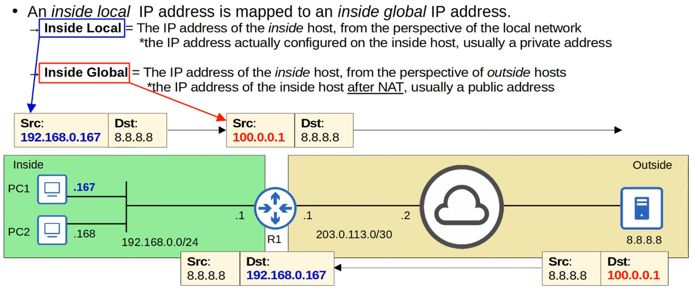

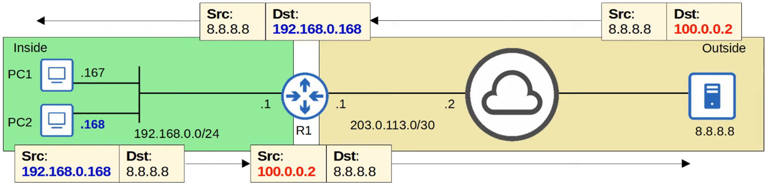

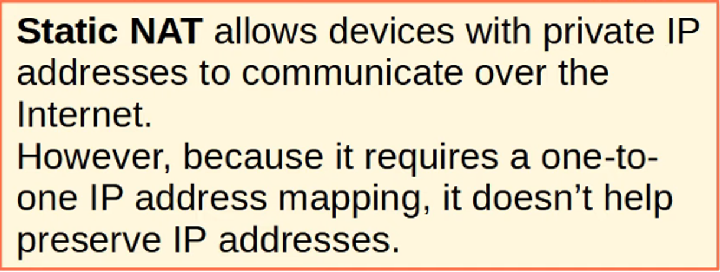

### **Important Note:**

* A **private IP address cannot be mapped to the same global IP address**.
* If a second mapping is attempted, **it will be rejected**.



## **Static NAT Configurations**

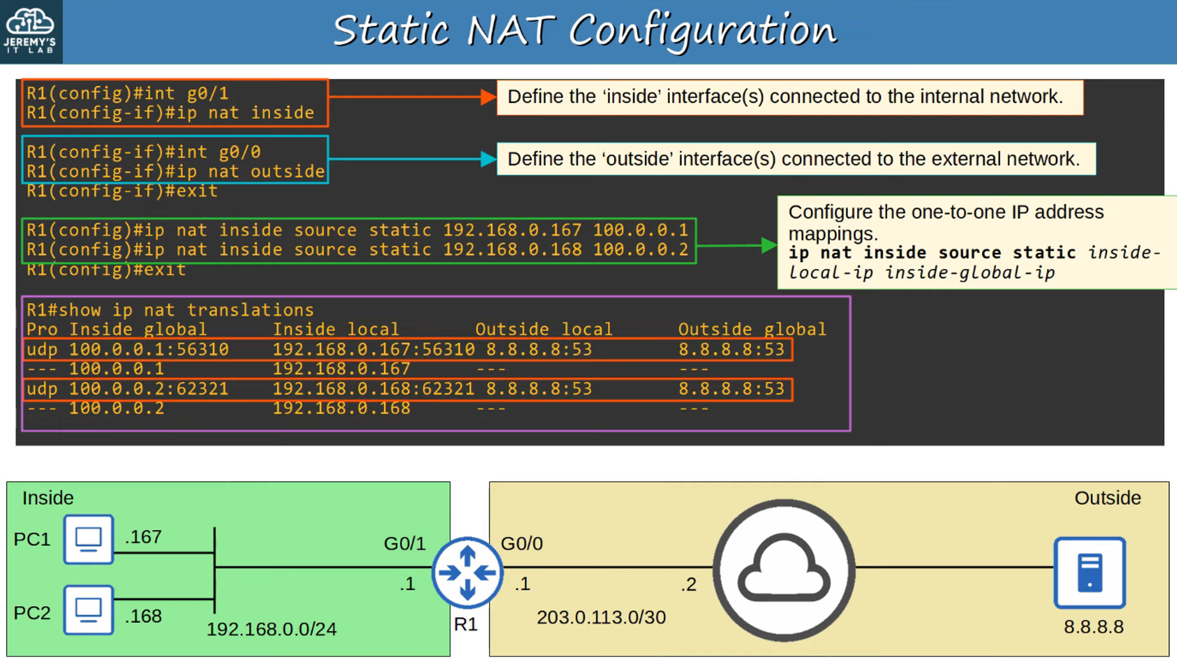

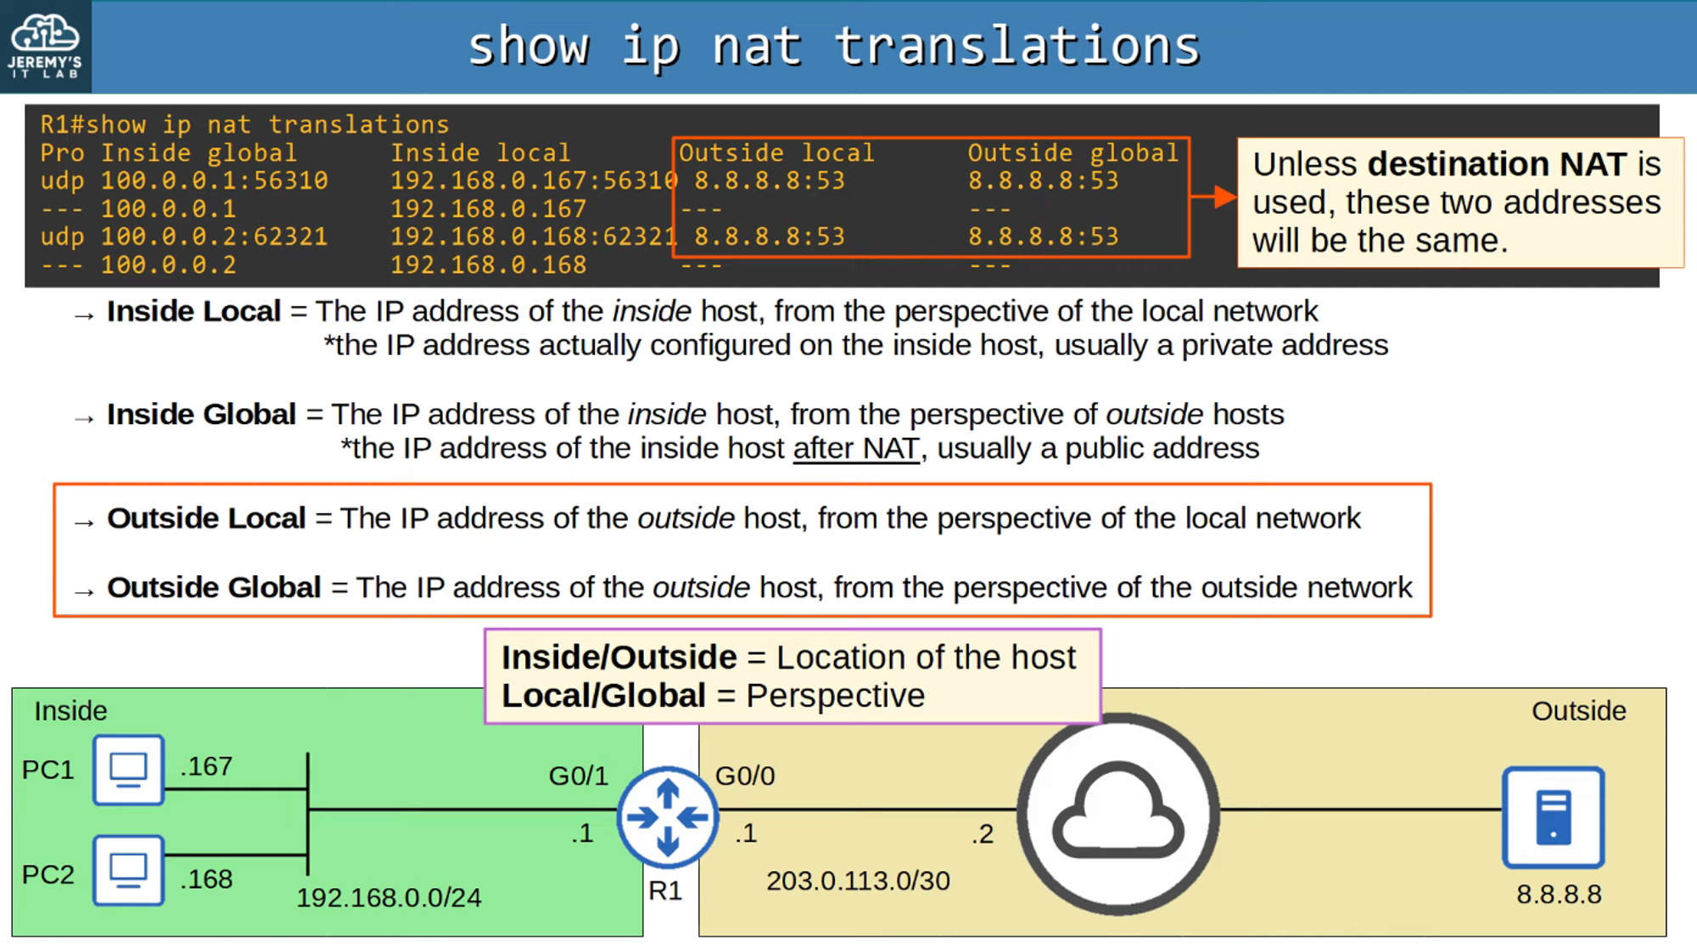

### **Useful Commands:**

#### **Clear NAT Translations**

R1#clear ip nat translation

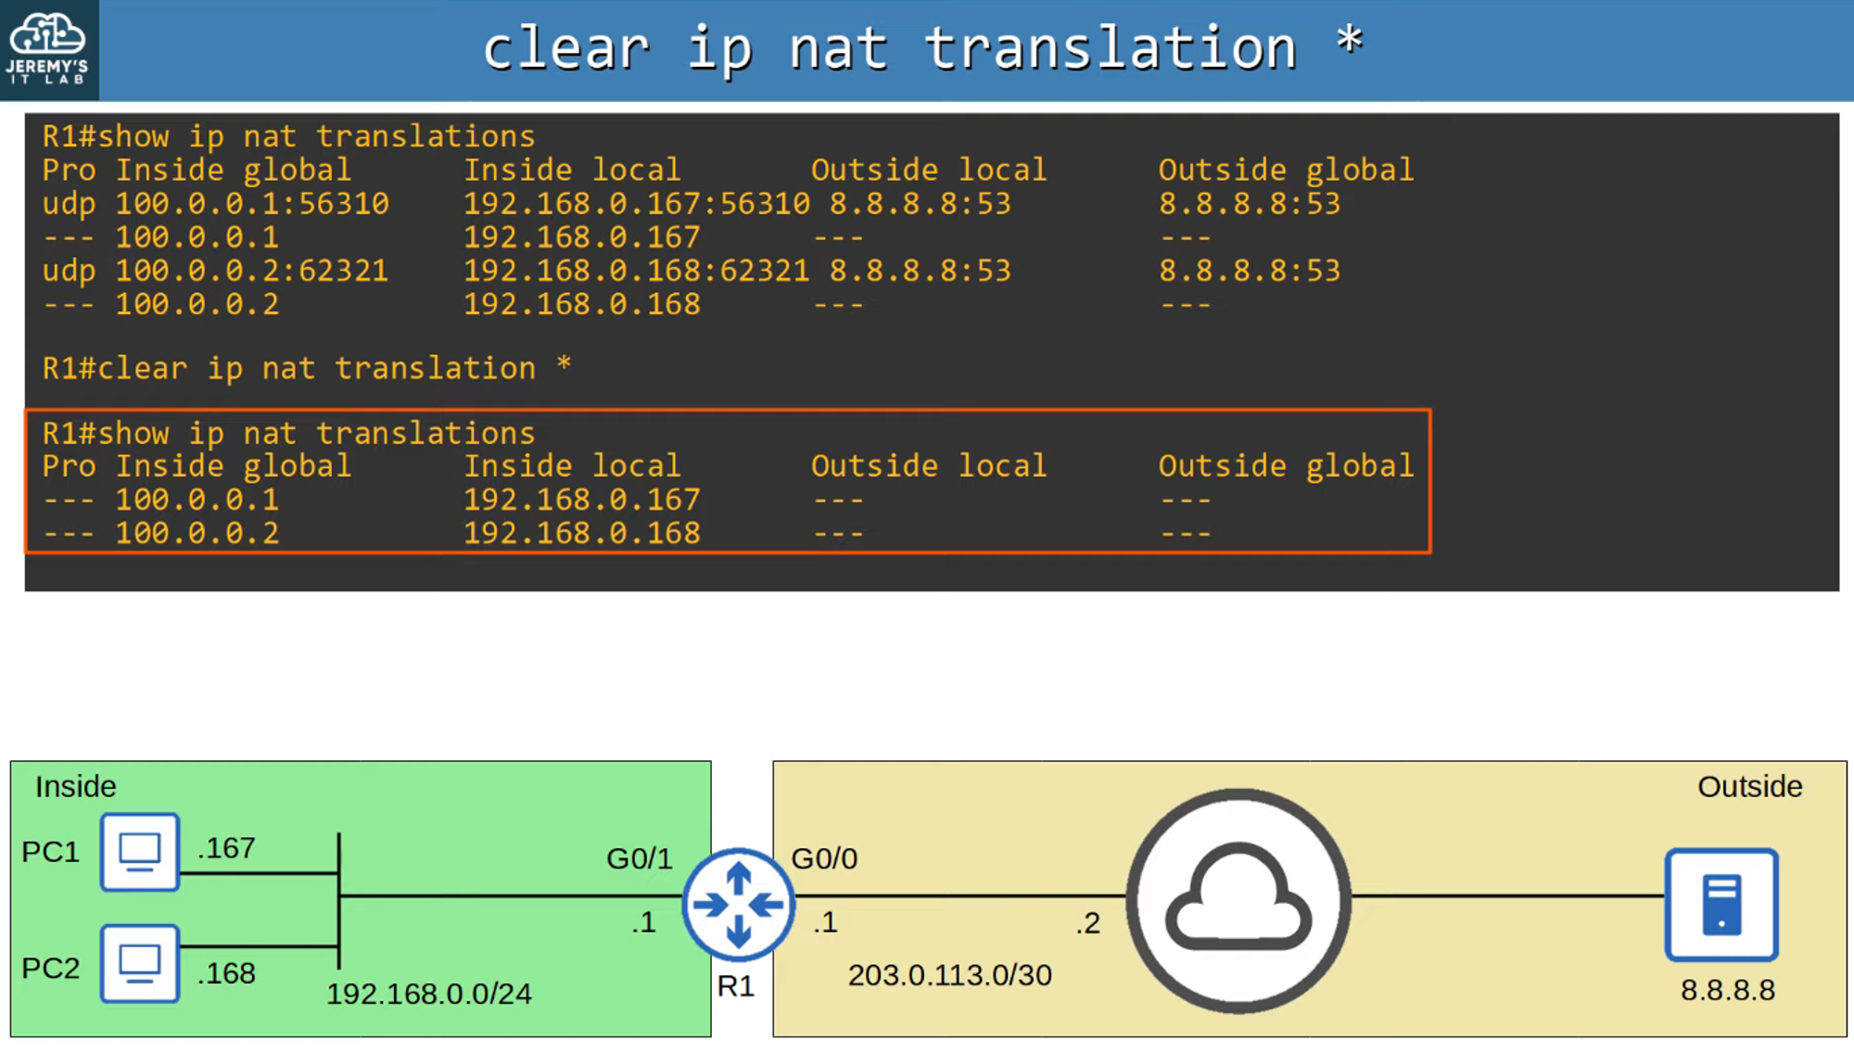

#### **Show NAT Statistics**

R1#show ip nat statistics

c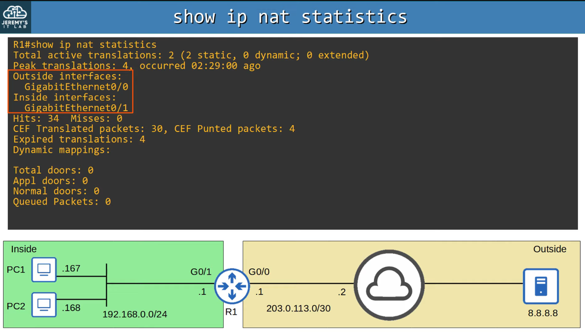

## **Command Review**

